Chapter 1, Problem 34.

Figure 1.32 shows the power consumption of a certain household in one day. Calculate: (a) the total energy consumed in kWh, (b) the average power per hour.

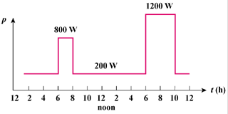

Figure 1.32
For Prob. 1.34.

